Clash of Clans Statistics Dashboard

Will Harper
Samford University
800 Lakeshore Dr
Birmingham, AL 35229
+1 770-371-7237
wharper1@samford.edu
Brian Toone
Samford University
800 Lakeshore Dr
Birmingham, AL 35229
+1 205 726 2960
brtoone@samford.edu

ABSTRACT
This project was an attempt to create a Clash of Clans dashboard for Clan leaders to use in order to see their clan’s stats. It consists of a dashboard, some Python programming, and the use of the Clash of Clans API. Connecting these three elements, the project should really help clan leaders in their efforts to manage their clans well.
Categories and Subject Descriptors
•Information systems~World Wide Web~Web services~RESTful web services
•Information systems~World Wide Web~Web services~Service discovery and interfaces.
General Terms
Management, Measurement, Design, and Reliability.
Keywords
API, dashboard, Python, and data pipeline.

INTRODUCTION
This project investigates pulling data from a REST API and setting up a dashboard displaying all this data via a python web application. One of the key challenges was formatting the data correctly to fit the dashboard.

BACKGROUND
There is an official Clash of Clans API that I used to pull data from. It is free and easy to use. Also, I used VS Code to create a Python data pipeline for the dashboard. The actual dashboard was made using a program called Plotly. I used some Python programing to write a method that makes a call to the Clash of Clans host server that returns API data about the clan members and their donation levels. Here are some screenshots of everything you can make requests for:
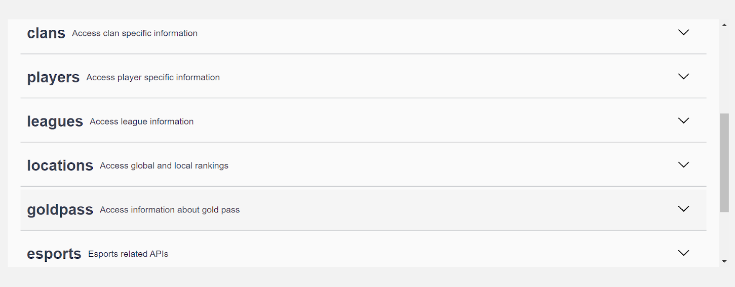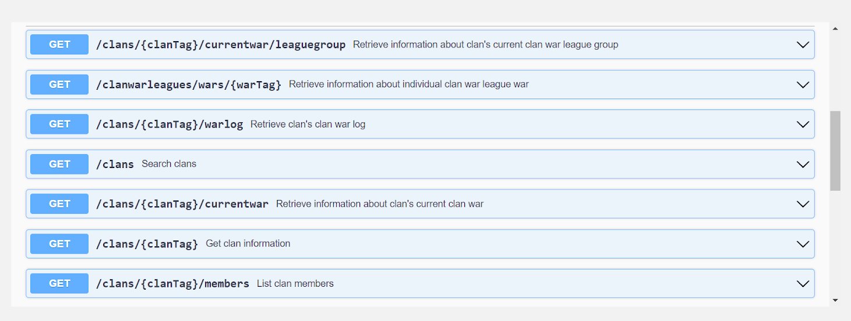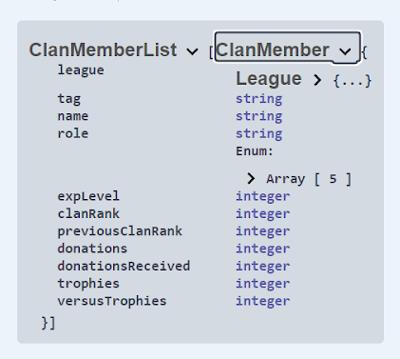
The API has several calls I can make. I intend to add several calls in the future, but for the project, I ended up only using the /clans/{clanTag}/members call in order to return all the members in my clan along with their league, tag, role, experience level, clan rank, previous clan rank, donations, donations received, trophies count, and their “versus” trophies count.

METHODOLOGY

Data Collection
I was pulling from the Clash of Clans API in order to get accurate and live data about the game. I just make a few calls to their servers in order to retrieve the free data that they are providing.

Permission to make digital or hard copies of all or part of this work for personal or classroom use is granted without fee provided that copies are not made or distributed for profit or commercial advantage and that copies bear this notice and the full citation on the first page. To copy otherwise, or republish, to post on servers or to redistribute to lists, requires prior specific permission and/or a fee.
Samford University Department of Math and Computer Science, May 2011, Birmingham, AL. Copyright 2011 Samford University…$10.00.

Converting the Data
Then I converted the data from raw data to CSV and then to something even more structured, a table. Whatever the dashboard requires is what I wanted to convert the data into.

Displaying the Results
Lastly, I displayed the data in a Plotly dashboard which has some nice sorting features for the clan leader using it. It displays the data nicely and simply in graph form and table form.

Results / Evaluation
I tested my software by running it a ton of times and pressing different buttons or doing things randomly over and over. I found out a lot of information that way, for example sometimes things would not reappear like they were supposed to if you spammed the button for them to disappear/reappear too many times. My intended audience is very niche. Out of everyone, I focus on players, and out of the players I focus on those who play Clash of Clans, and out of those players, I focus on clan leaders. I have not delivered this to the intended audience for two primary reasons. One is I would like to work on it a little more to improve functionality, but also, I would don’t know any other clan leaders that I could send this to.

CONCLUSION
My conclusion is that I have a dashboard built that displays data that I pulled from the Clash of Clans API and converted to be compatible with the data frames in the dashboard.

What you learned
I learned a lot about how data analysis works. I made sure to take extra note of the general structure and understand how everything flows. I learned a lot about Python, pandas, data frames, data pipelines, APIs, and dashboards! I am really grateful for this project as it has helped me prepare for my upcoming internship.

Where to go from here
This has opened up several interesting research avenues for me, especially with regards to this specific project. I am planning to spend more time on this project, improving it and making it more user-friendly and provide a lot of different graphs for the clan leader to utilize. I will be learning much more about Plotly and all that I can do with it.

ACKNOWLEDGEMENTS
I just want to thank a couple people for their contribution in some way to this project. First off, I would like to thank Matthew Lad and Alan Crisologo for the idea and the initial motivation, as well as Ian for all the help he gave me when I was starting out. He also was responsible for the discovery of the Clash of Clans API as well as my interest in Plotly. Lastly, I would like to thank my professor, Brian Toone, for all of his patience and contribution at all hours of the night to help me get this done.

REFERENCES
Plotly. Https://plotly.com. Accessed April 20, 2022.
Clash of Clans API. Https://developer.clashofclans.com/#/. Accessed April 18, 2022.
Visual Studio Code IDE. Python Programing IDE. Accessed April 18, 2022.

